**Neural Networks & Deep Learning - ICP 2**

**GitHub Link**

[**https://github.com/YaminiSai786/CS5720-Neural-Networks-Deep-Learning---ICP**](https://github.com/YaminiSai786/CS5720-Neural-Networks-Deep-Learning---ICP)

**Program 1**

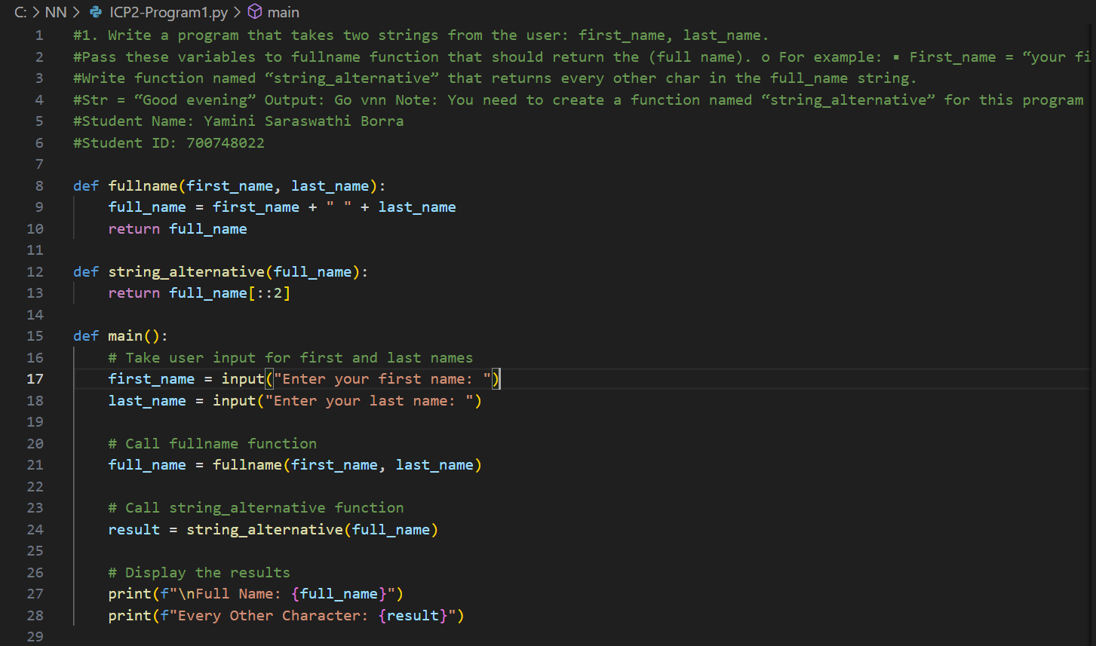

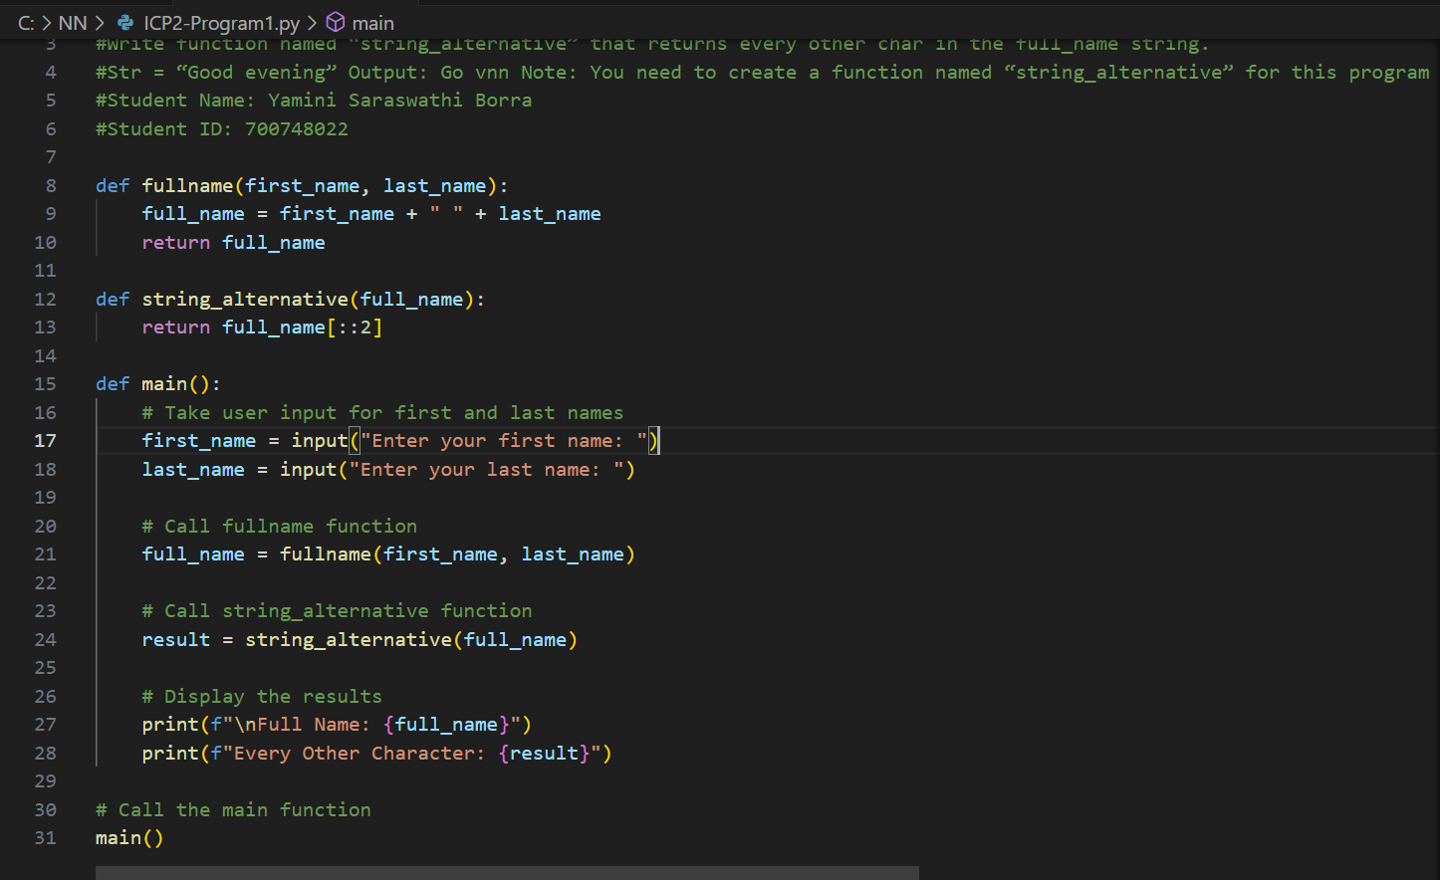

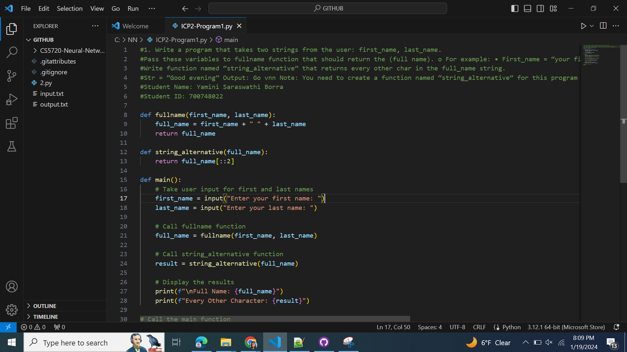

**Program 1 - Result**

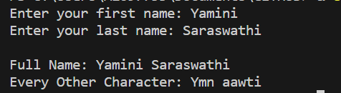

**Program 2**

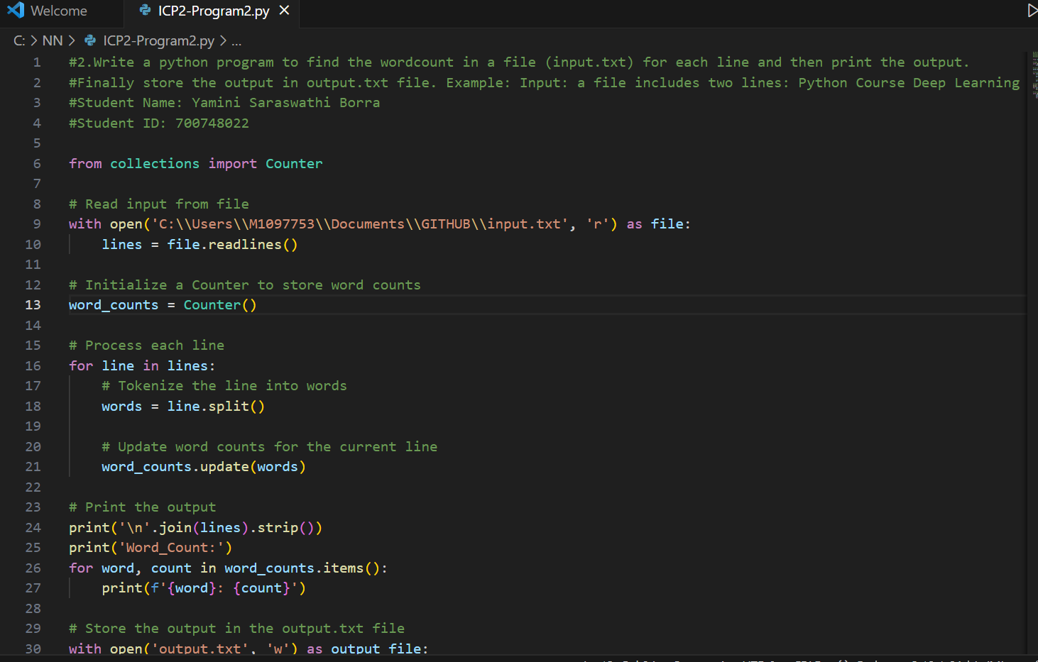

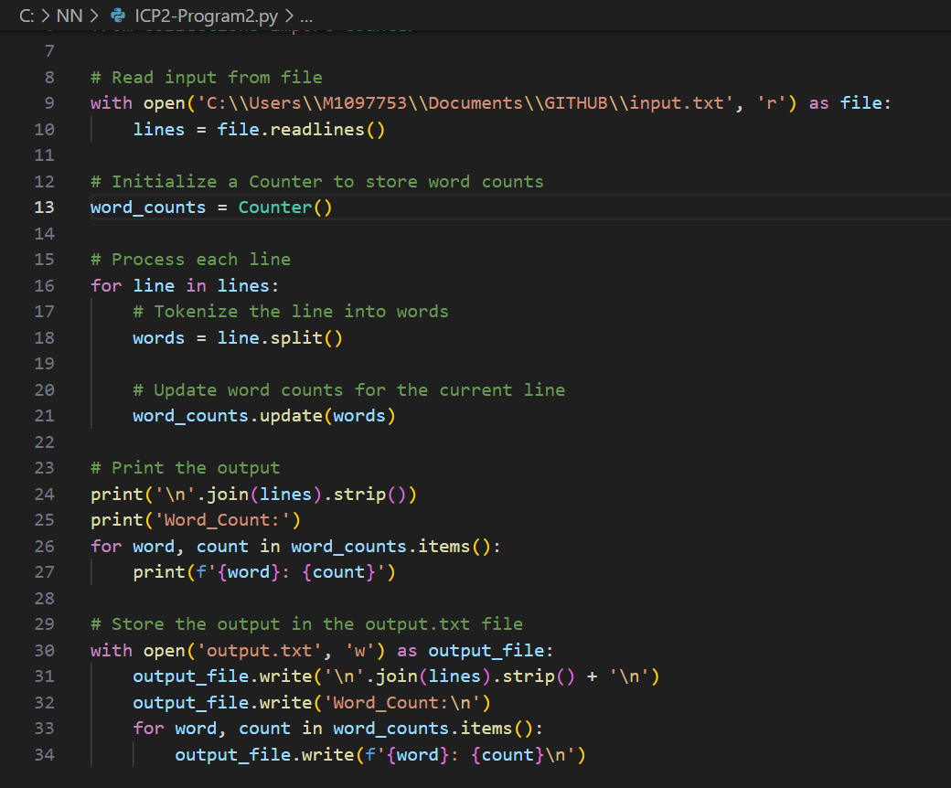

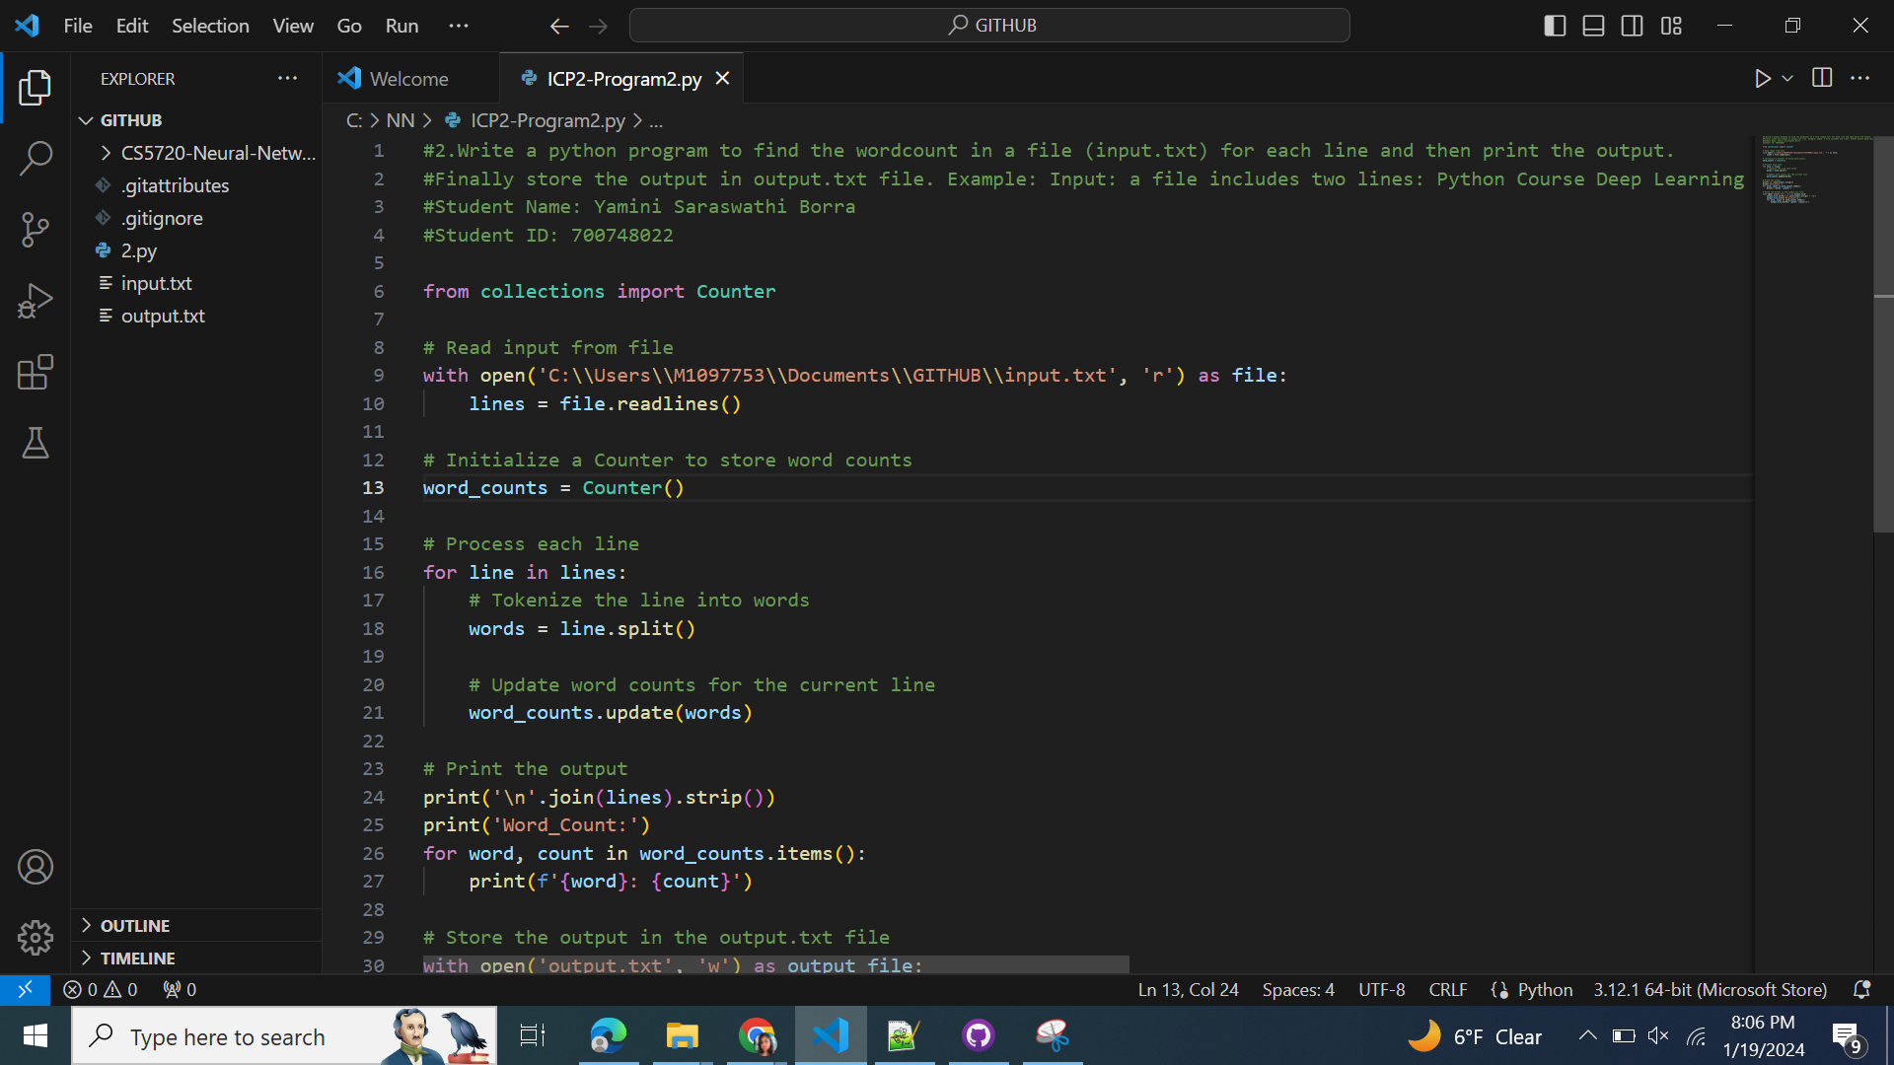

**Program 2 - Result**

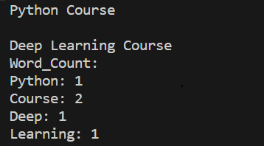

**Program 3**

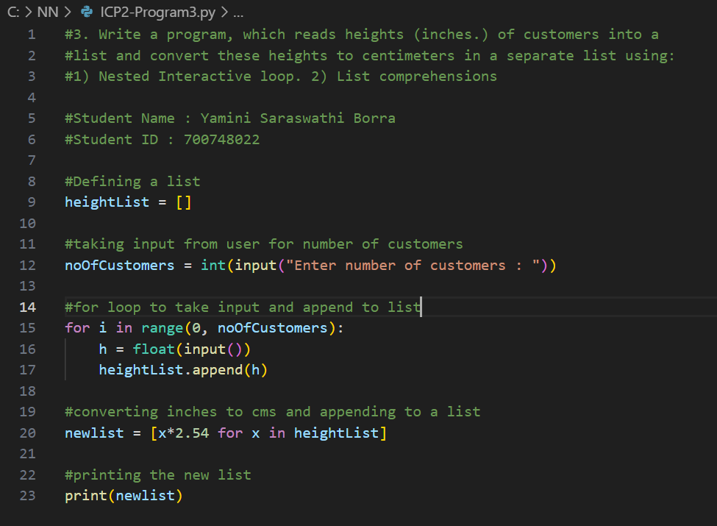

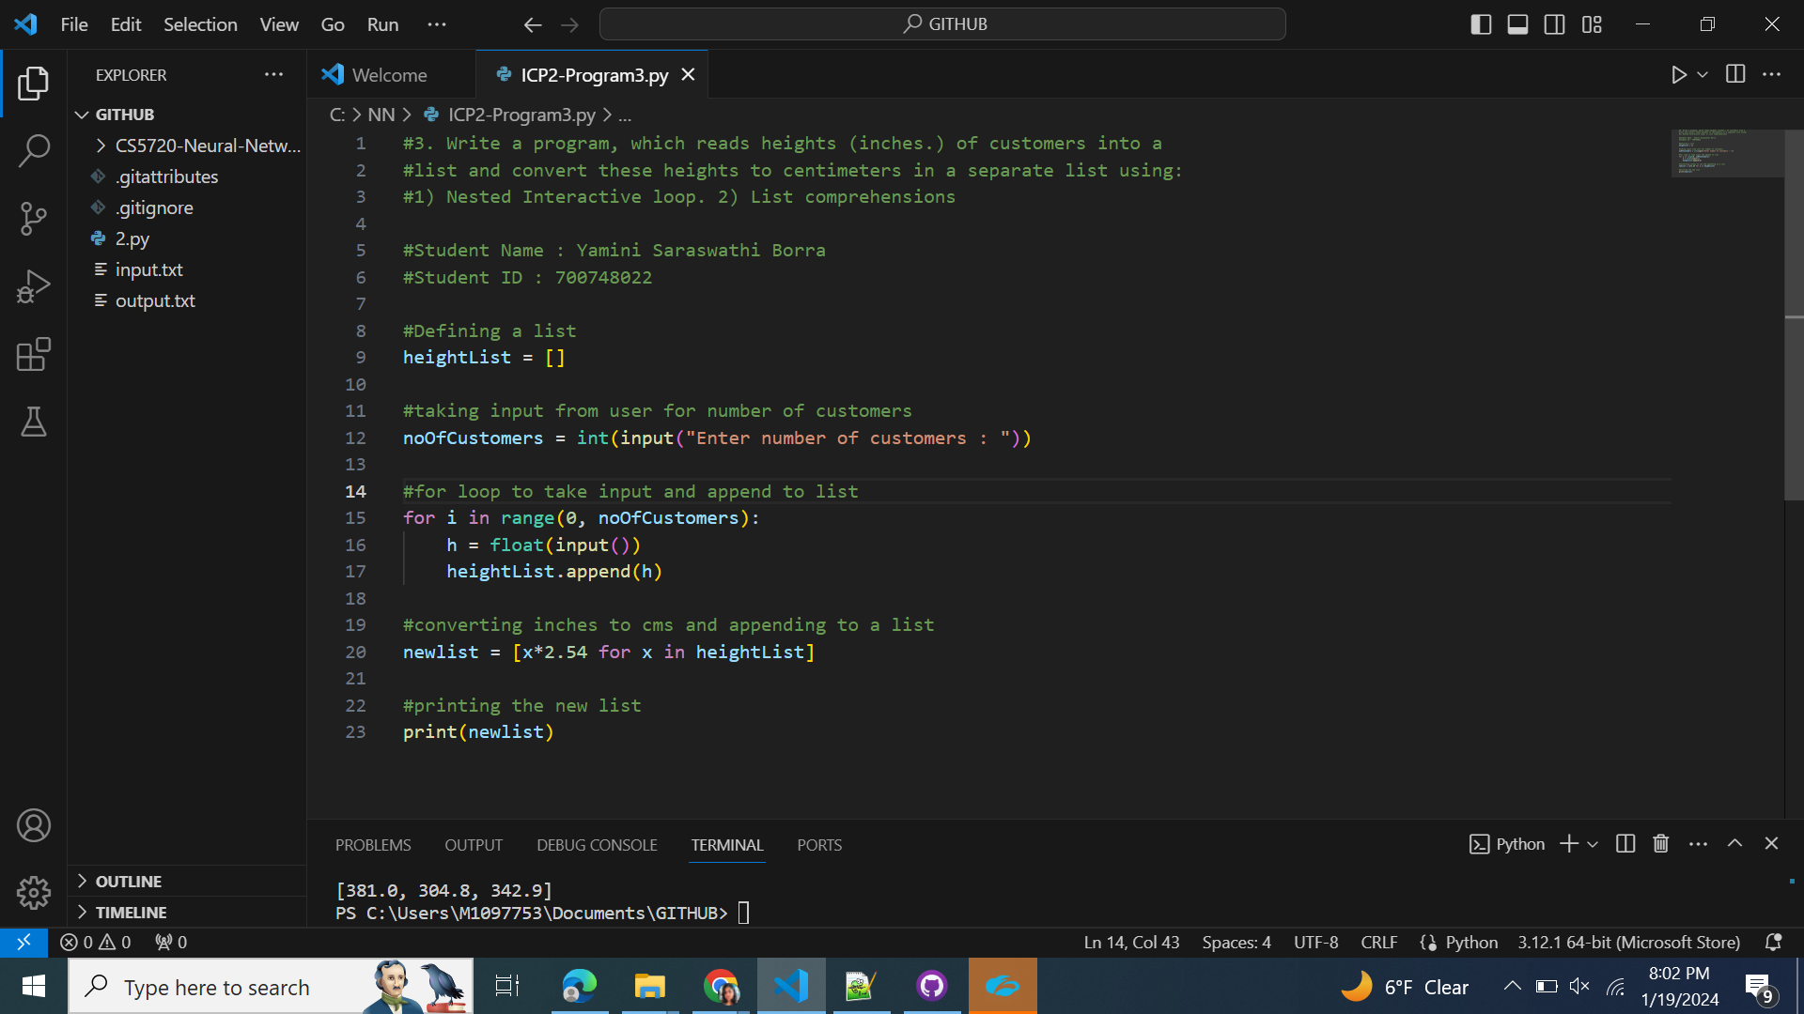

**Program3 - Result**

